Datasheet
EPP Duct
ø160 Elbow 90°

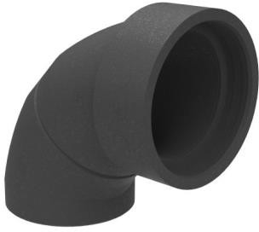
Inner diameter | 160 [mm]
Material | EPP
ζ (flow resistance) | 0.2 [-]
λ (thermal conductivity) | 0.039 [W/m∙K]
Airtightness class | C
Measured with: Temperature | 32 [°C]
Patm | 1004 [mBar]
ρ (density) | 1.146 [kg/m³]

Flow
[m3/h] [l/s]
50 13.9
150 41.7
250 69.5
350 97.2
450 125.0
Velocity [m/s] 0.7
2.1
3.5
4.8
6.2
Pressure loss
[Pa] 0.1
0.5
1.4
2.7
4.4

Pressure loss
10.0

1.0
Total pressure loss [Pa]

0.1
50 150 250 350 450
Flow [m3/h]

Ver. 140303 ID: 11 0067

