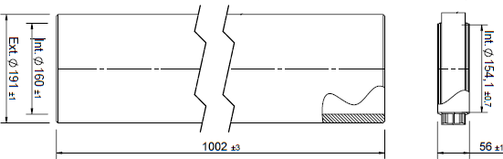

General information

Application insights

Description Article number Material Material socket
Colour
Wall Thickness Density

Application Application use Inner Diameter Outer Diameter

Extension insulated EPS 160 L=1000
40.048.05.60
EPS
PP
Grey
15 mm
45 g/l

Ventilation Supply/Extract Ø160 mm Ø190 mm

Technical specifications

Air tightness class Temperature range Thermal conductivity Pressure loss
Fire resistance class Maximum air flow R-Value
D [EN12237]
-25 / +80 °C
λ 0 , 032 W/(m.K)
0,19ζ
E [EN 13501-1]
450 m3/h
0,42 m²K/W

Supply& Extract
Flow rates vs. Pressure loss

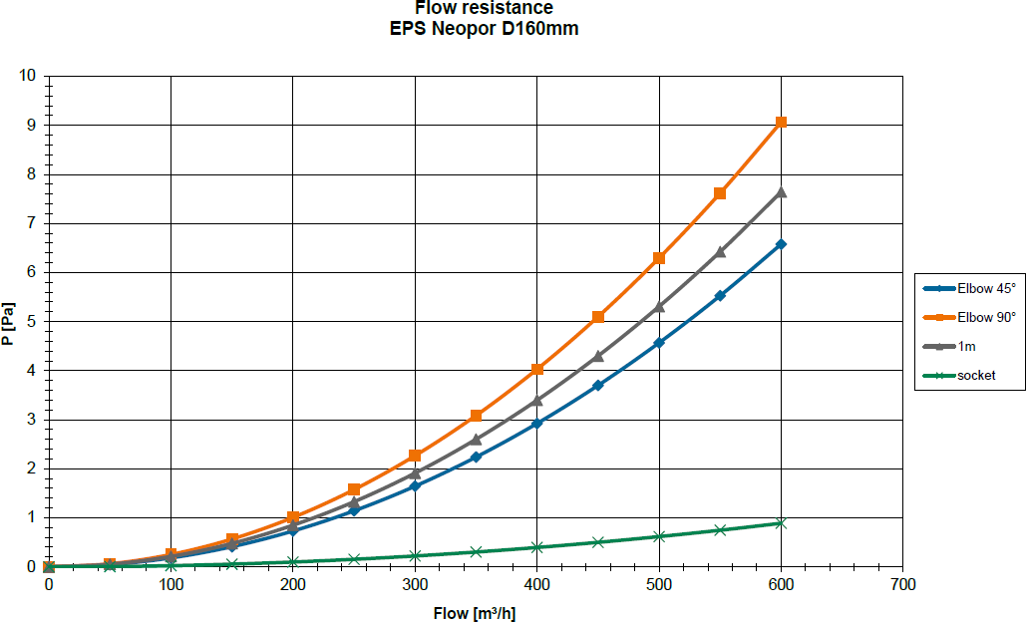

Flow rates and Velocity
